Dear Parents or Guardians:
This is to inform you that your selection on the Parent Connect Annual Enrollment documents indicates that your child’s information and pictures are NOT to be included in the yearbook. We wanted to give you the opportunity to correct it if it is an error.

1. Please log into Parent Connect through CUSD.com or Nelson.cusd.com. If you need your login information, please click on the Forgot PIN/Password in the upper right corner of the page.
2. In Parent Connect, click on the link to Annual Information Update in the upper right corner.
3. Find Section 2, Release of Information.
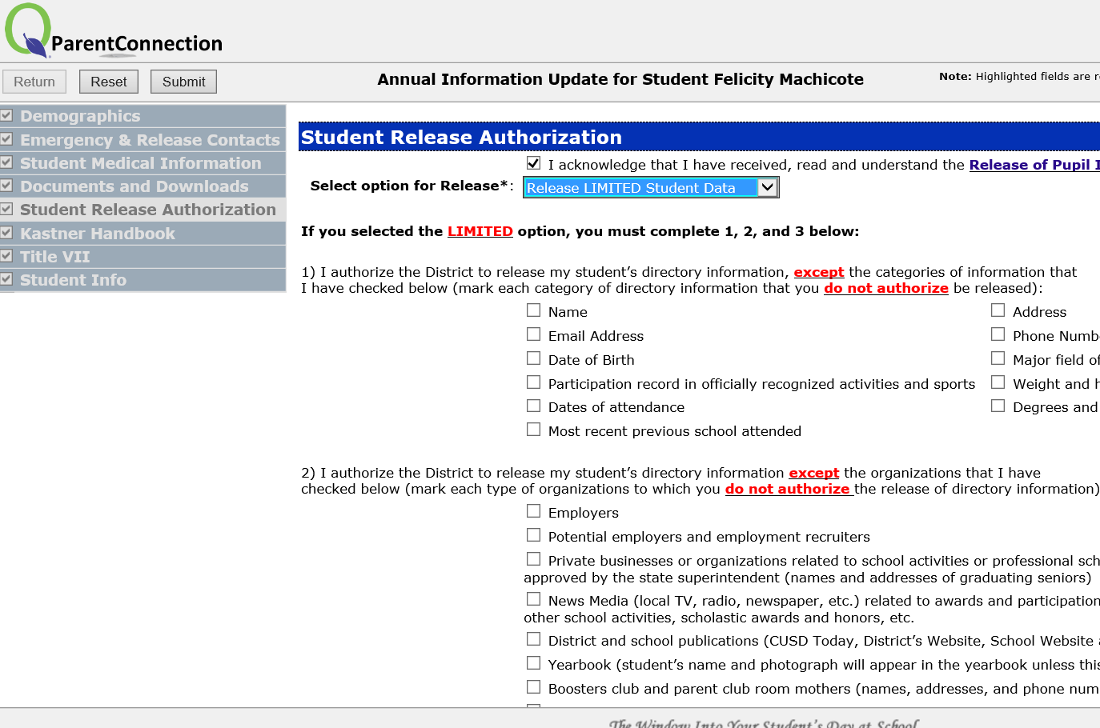
4. Change the option for release to Limited Student Data.

5. Scroll down to the Yearbook box and uncheck it if there is a check in the box.

6. In upper left corner, click the SUBMIT button when you are sure you have made the above-noted changes.

If you need assistance, please contact Mrs. Machicote in the front office, 327-7600. You can stop by the office and make the changes using the office computer. Miss Monica needs these changes made by Monday, January 13th so she can begin work on the yearbook.
Thank you!

